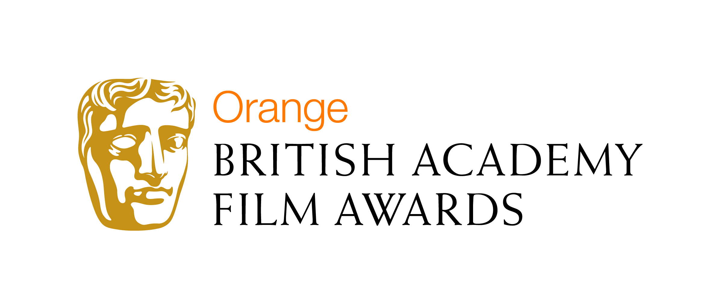

The popular public award at the Orange British Academy Film Awards changes its name and format to allow Orange Wednesdays customers to decide the final five nominees

London, 23 September 2010: Today Orange announced that Orange Wednesdays customers will now have a decisive say on who is nominated for the established Orange Rising Star Award, the only award at the Orange British Academy Film Awards to be voted for by the British public.

This announcement comes at the same time as the call for the 2011 Orange Wednesdays Rising Star Award recommendations goes out to all industry professionals, who are asked to put forward talent that they forecast to be stars of the future.

The role and purpose of the award for identifying talent destined for stardom will remain the same. The format will change to give Orange Wednesdays customers the chance to have their say on the five nominations, which will then be voted on by the British public before the winner is crowned at the Orange British Academy Film Awards on 13th February 2011. To reflect the new role of the Orange Wednesdays customer, the award name has changed to the Orange Wednesdays Rising Star Award.

Orange has a long standing association with film through its hugely successful Orange Wednesdays initiative. This year the Orange Wednesdays Rising Star Award will strengthen that association further, bringing BAFTA and fans of the much-loved Orange Wednesdays closer together.

Finola Dwyer, Orange Wednesdays Rising Star Jury Chair, comments: “I am extremely pleased to be working with Orange on the Award this year. It is a truly credible award that opens up all avenues of opportunity to new talent and it is a fantastic way to bring new rising stars into the public eye.”

Andrew Pearcey, Head of Brand Sponsorships and Partnerships at Orange, comments: “This year, we really want to bring the excitement of the Orange BAFTAs to our Orange Wednesdays audience and this is the perfect opportunity to do that. Involving Orange Wednesdays customers in the decision making process ensures the award format remains fresh and relevant while continuing to shine the spotlight on film talent of the future. To support this initiative we also have more exciting plans to come throughout the BAFTA campaign, that will bring Orange Wednesdays cinema fans even closer to the glitz and glamour associated with the Orange British Academy Film Awards.”

The Orange Wednesdays Rising Star Award was created in honour of Mary Selway, the highly respected BAFTA-winning casting director whose career spanned three decades and over 90 films before she died in 2004. Previous winners include James McAvoy in 2006, Eva Green in 2007, Shia LaBeouf in 2008, Noel Clarke in 2009 and Kristen Stewart in 2010.

The deadline for recommendations is Friday 1 October. For further information on last year’s Orange Rising Star Award go to orange.co.uk/bafta and then email your nomination to bafta2011@cakegroup.com

-Ends-

For more information please contact:

Claire Timlett at M&C Saatchi:
Tel: 0207 543 4580
Email: claire.timlett@mcsaatchi.com

Notes to Editors

About BAFTA
The British Academy of Film and Television Arts is an independent charity that supports, develops and promotes the art forms of the moving image by identifying and rewarding excellence, inspiring practitioners and benefiting the public. In addition to its Awards ceremonies, BAFTA has a year-round Learning & Events programme that offers unique access to some of the world’s most inspiring talent through workshops, masterclasses and lectures, connecting with audiences of all ages and backgrounds across the UK. BAFTA relies on income from membership subscriptions, individual donations, trusts, foundations and corporate partnerships to support its ongoing outreach work. For further information, visit www.bafta.org.

About Orange UK
Orange is the key brand of the France Telecom Group, one of the world's leading telecommunications operators. With 131.8 million customers, the Orange brand now covers Internet, television and mobile services in the majority of countries where the Group operates.

In the UK, Orange provides high quality GSM coverage to 99% of the UK population, and 3G coverage to more than 93%. At the end of March 2010, Orange had more than 17.305 million customers in the UK - 16.442 million active mobile customers and approximately 863,000 fixed line internet customers.

Orange and any other Orange product or service names included in this material are trade marks of Orange Brand Services Limited.

On July 1 2010, the company became part of Everything Everywhere, one company that runs two of Britain's most famous brands - Orange UK and T-Mobile UK - with plans to transform the industry by giving customers instant access to everything, everywhere, offering them the best value, best choice and best network coverage in the country. Everything Everywhere Limited is registered at Hatfield Business Park, Hatfield, Hertfordshire, AL10 9BW under the registered company number 02382161.

For more information please call the Orange Press Office 0870 3731500, or visit www.orange.co.uk/newsroom <http://www.orange.co.uk/newsroom>

